Chapter 11, Solution 36.

- I_{rms} = 10 A
- 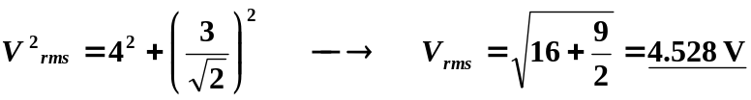 (checked)
- 
 